|  |
| --- |
|  |
| GROUP INFINITY |
| **GROCERY MANAGEMENT SYSTEM** |
|  |
|  |
|  |



|  |
| --- |
|  |

**Acknowledgement**

We have taken efforts in this project. However it would have not been possible without the kind of support and help of many individuals. We would like to extend our sincere thanks to all of them.

We are highly indebted to our Lecturer, Mr.Rajitha Gayan jayasekara for guiding us and paying constant supervision to our activities done in the lab and also providing necessary information regarding the project.

We should thank and appreciate also our class mates in developing the project and people who willingly helped us.

Table of Contents

1. .NET Framework
   1. What is .NET Framework
   2. The objectives of .NET Framework
   3. The advantages and disadvantages of using .NET Framework
   4. New features of .NET Framework
2. DIAGRAMS
   1. Use case diagram
   2. Class diagram
3. Microsoft Visual Studio – c#.NET design an coding
   1. Welcome page
   2. Login page
   3. Main menu page
   4. Employee page
   5. Customer page
   6. Supplier page
   7. Manager page
   8. Customer order page
   9. Stock details page
   10. Logout page
4. Conclusion

|  |
| --- |
| Name of the Project – Grocery Management System |
| Course Name – Diploma In Information Technology |
| Batch No. – 517 |
| Group Name – Infinity |
| Name of the Lecturer – Mr.Rajitha Gayan Jayasekara |
| Date Submitted – 1st May 2018 |
| Names of Group Members :   |  |  |  | | --- | --- | --- | | **Reg.No** | **Name** | **Signature** | | **COL/A-059985** | **Kithumina Peris** |  | | **COL/E-00418** | **T.F.F. Sookoor** |  | | **COL/A-059931** | **Yeran Kodithuwakku** |  | | **COL/A-05984** | **Randima Fernando** |  | | **COL/A-059738** | **Dinush Silva** |  | |  |  |  | |

1. .NET FRAMEWORK



* 1. What is .NET Framework?

*The .NET Framework is a software development framework from Microsoft. It provides a controlled programming environment where software can be developed, installed and executed on windows based operating systems.

* 1. The objectives of .NET Framework

*The .NET Framework is designed to fulfill the following objectives:

1. To provide a consistent object-oriented programming environment whether object code is stored and executed locally, executed locally but Internet-distributed, or executed remotely
2. To make the developers experience consistent across widely varying types of apps, such as windows –based apps and Web-based apps.
3. To provide a code execution environment that minimizes conflicts that arises in software development.
4. To provide a code- execution environment that eliminates the performance problems of scripted or interrupted environments.
5. To build all communication on industry standards to ensure that code based on the .NET Framework integrates with any other code.

1.3 The advantages and disadvantages of .NET Framework

*Advantages

1. Development of software’s is very much secure in .NET framework compared to many other platforms

1. With .NET Framework the quantity of codes used in large web applications can be reduce.
2. .NET platform compatible with multi-languages.
3. The .NET platform is a server sided technology, hence .NET code will perform on the server before getting directed to the web server.
4. Drag and Drop of various functions is also available in .NET Framework.

*Disadvantages

1. Time consumption may be more in some situations due to regularly occurring of garbage collection for reclaiming memory.
2. In older version of windows, the framework may not be pre-installed. Hence it should be checked first and if not, we should follow the guidelines in the user manual.
3. Applications running in managed environments may require more system resources compared to applications that access machine resources more directly.
4. Newer visions of .NET Framework are not pre-installed in any version windows.
5. Security is comparatively lesser and many familiar things can reveal as reverse engineering of codes is easy. However, many techniques have been developed to protect privacy to a greater extent.

1.4 New features of .NET Framework

1. ASP.NET.
2. Character categories.
3. Cryptography.
4. Sqlclient.
5. Windows communication foundation.
6. Windows presentation foundation.
7. Windows workflow foundation.
8. Click Once.

2. Diagrams

2.1 Use case diagram

Cashier

Supplier

Customer

Manager

2.2 Class Diagram

|  |
| --- |
| Customer |
| +Customer Name  +Address  +Tel.No |
| Add()  Delete()  Main() |

|  |
| --- |
| Cashier |
| +Name  +Address  +Tel.No |
| Add()  Delete()  Main() |

|  |
| --- |
| Manager |
| +Name  +Address  +Tel.No |
| Add()  Delete()  Main() |

|  |
| --- |
| Stocks |
| +Itemcode  +Quantity  +Unit Price  +Total Price |
| Add()  Delete()  Main() |

|  |
| --- |
| Order |
| +Itemcode  +Quantity  +Unit Price  +Total Price |
| Add()  Delete()  Main() |

|  |
| --- |
| Supplier |
| +Name  +Address  +Tel.No |
| Add()  Delete()  Main() |

3. Microsoft Visual Studio – c#.NET design an coding

3.1 Welcome Page



Coding

using System;

using System.Collections.Generic;

using System.ComponentModel;

using System.Data;

using System.Drawing;

using System.Linq;

using System.Text;

using System.Threading.Tasks;

using System.Windows.Forms;

namespace Stock_Management_System

{

public partial class Welcome : Form

{

public Welcome()

{

InitializeComponent();

}

private void button1_Click(object sender, EventArgs e)

{

this.Hide();

Login ss = new Login();

ss.Show();

}

private void Welcome_Load(object sender, EventArgs e)

{

}

}

}

3.2 Login Page

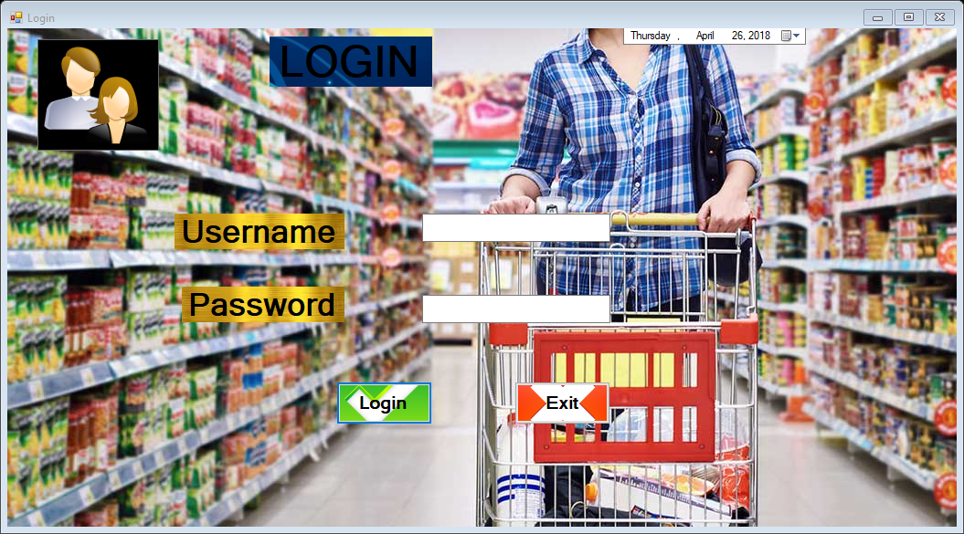

Coding

using System;

using System.Collections.Generic;

using System.ComponentModel;

using System.Data;

using System.Drawing;

using System.Linq;

using System.Text;

using System.Threading.Tasks;

using System.Windows.Forms;

using System.Data.SqlClient;

namespace Stock_Management_System

{

public partial class Login : Form

{

public Login()

{

InitializeComponent();

}

private void button2_Click(object sender, EventArgs e)

{

this.Close();

}

private void button1_Click(object sender, EventArgs e)

{

SqlConnection con = new SqlConnection(@"Data Source=(LocalDB)\MSSQLLocalDB;AttachDbFilename=C:\Users\YERAN\Documents\Data.mdf;Integrated Security=True;Connect Timeout=30");

SqlDataAdapter sda = new SqlDataAdapter("Select Count(*) From Login where Username='"+textBox1.Text +"'and Password ='" +textBox2.Text + "' ",con);

DataTable dt = new DataTable();

sda.Fill(dt);

if (dt.Rows[0][0].ToString() == "1")

{

this.Hide();

MainMenu ss = new MainMenu();

ss.Show();

}

else

{

MessageBox.Show("Please Check Your Username and Password");

}

}

private void Login_Load(object sender, EventArgs e)

{

}

}

}

3.3 Main Menu Page

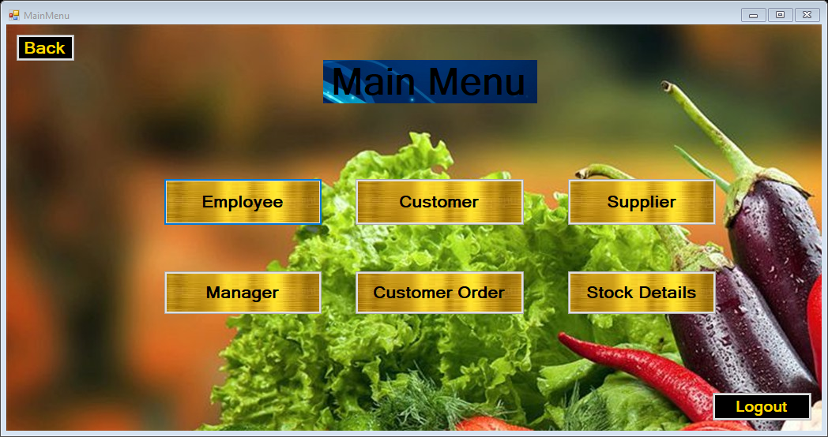

Coding

using System;

using System.Collections.Generic;

using System.ComponentModel;

using System.Data;

using System.Drawing;

using System.Linq;

using System.Text;

using System.Threading.Tasks;

using System.Windows.Forms;

namespace Stock_Management_System

{

public partial class MainMenu : Form

{

public MainMenu()

{

InitializeComponent();

}

private void button1_Click(object sender, EventArgs e)

{

this.Hide();

Login ss = new Login();

ss.Show();

}

private void MainMenu_Load(object sender, EventArgs e)

{

}

private void button3_Click(object sender, EventArgs e)

{

this.Hide();

Employee ss = new Employee();

ss.Show();

}

private void button5_Click(object sender, EventArgs e)

{

this.Hide();

Customer ss = new Customer();

ss.Show();

}

private void button2_Click(object sender, EventArgs e)

{

this.Hide();

Logout ss = new Logout();

ss.Show();

}

private void button4_Click(object sender, EventArgs e)

{

this.Hide();

Managercs ss = new Managercs();

ss.Show();

}

private void button7_Click(object sender, EventArgs e)

{

this.Hide();

Supplier ss = new Supplier();

ss.Show();

}

private void button6_Click(object sender, EventArgs e)

{

this.Hide();

Customerorder ss = new Customerorder();

ss.Show();

}

private void button8_Click(object sender, EventArgs e)

{

this.Hide();

Supplier ss = new Supplier();

ss.Show();

}

}

}

3.4. Employee page

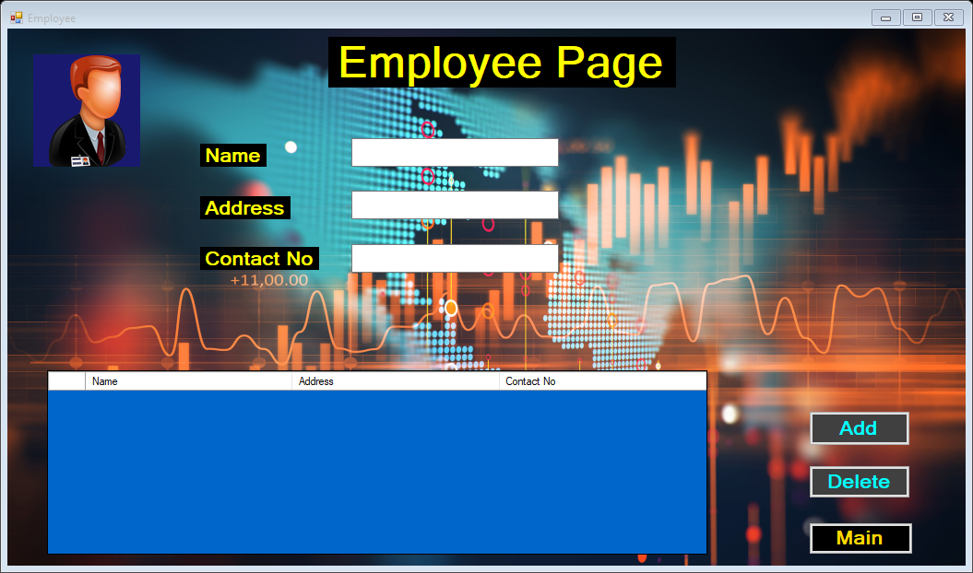

Coding

using System;

using System.Collections.Generic;

using System.ComponentModel;

using System.Data;

using System.Drawing;

using System.Linq;

using System.Text;

using System.Threading.Tasks;

using System.Windows.Forms;

using System.Data.SqlClient;

namespace Stock_Management_System

{

public partial class Employee : Form

{

SqlConnection con = new SqlConnection(@"Data Source=(LocalDB)\MSSQLLocalDB;AttachDbFilename=C:\Users\YERAN\Documents\Data.mdf;Integrated Security=True;Connect Timeout=30");

public Employee()

{

InitializeComponent();

}

private void button1_Click(object sender, EventArgs e)

{

this.Hide();

MainMenu ss = new MainMenu();

ss.Show();

}

private void button2_Click(object sender, EventArgs e)

{

SqlCommand cmd = con.CreateCommand();

cmd.CommandType = CommandType.Text;

cmd.CommandText = "insert into Employee values('" + textBox1.Text + "','" + textBox2.Text + "','" + textBox3.Text + "')";

con.Open();

cmd.ExecuteNonQuery();

disp();

MessageBox.Show("Employee Added Successfully ");

con.Close();

}

private void button3_Click(object sender, EventArgs e)

{

if (e == null)

{

throw new ArgumentNullException(nameof(e));

}

try

{

string Name = textBox1.Text;

string query_delete = "delete from [Employee] where Name ='" + Name + "'";

SqlCommand cmd = new SqlCommand(query_delete, con);

con.Open();

cmd.ExecuteNonQuery();

disp();

MessageBox.Show("Record Deleted Successfully");

}

catch (Exception ex)

{

MessageBox.Show("Error While Deleting !" + ex);

}

finally

{

con.Close();

}

}

private void Employee_Load(object sender, EventArgs e)

{

}

public void disp()

{

SqlCommand cmd = con.CreateCommand();

cmd.CommandType = CommandType.Text;

cmd.CommandText = "select * from Employee";

cmd.ExecuteNonQuery();

DataTable dt = new DataTable();

SqlDataAdapter da = new SqlDataAdapter(cmd);

da.Fill(dt);

dataGridView1.DataSource = dt;

}

}

}

3.5. Customer page

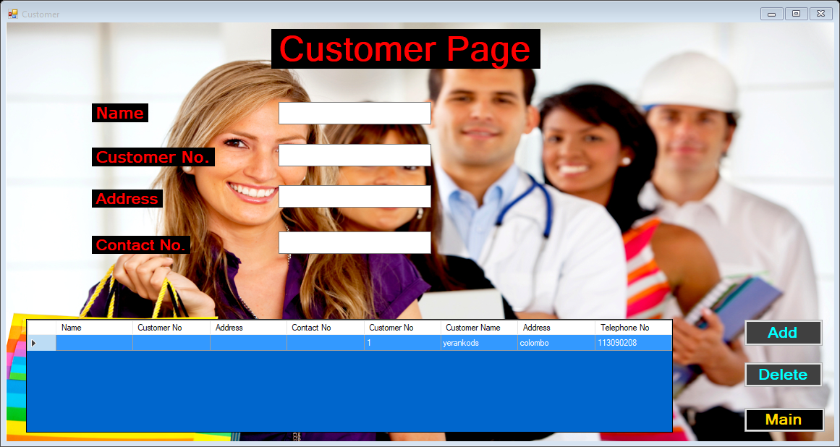

Coding

using System;

using System.Collections.Generic;

using System.ComponentModel;

using System.Data;

using System.Data.SqlClient;

using System.Drawing;

using System.Linq;

using System.Text;

using System.Threading.Tasks;

using System.Windows.Forms;

namespace Stock_Management_System

{

public partial class Customer : Form

{

SqlConnection con = new SqlConnection(@"Data Source=(LocalDB)\MSSQLLocalDB;AttachDbFilename=C:\Users\YERAN\Documents\Data.mdf;Integrated Security=True;Connect Timeout=30");

public Customer()

{

InitializeComponent();

}

private void button1_Click(object sender, EventArgs e)

{

this.Hide();

MainMenu ss = new MainMenu();

ss.Show();

}

private void button2_Click(object sender, EventArgs e)

{

SqlCommand cmd = con.CreateCommand();

cmd.CommandType = CommandType.Text;

cmd.CommandText = "insert into Customer values('" + textBox1.Text + "','" + textBox2.Text + "','" + textBox3.Text + "','" + textBox4.Text + "')";

con.Open();

cmd.ExecuteNonQuery();

disp();

MessageBox.Show("Customer Added Successfully ");

con.Close();

}

private void Customer_Load(object sender, EventArgs e)

{

}

public void disp()

{

SqlCommand cmd = con.CreateCommand();

cmd.CommandType = CommandType.Text;

cmd.CommandText = "select * from Customer";

cmd.ExecuteNonQuery();

DataTable dt = new DataTable();

SqlDataAdapter da = new SqlDataAdapter(cmd);

da.Fill(dt);

dataGridView1.DataSource = dt;

}

private void button3_Click(object sender, EventArgs e)

{

try

{

string Name = textBox1.Text;

string query_delete = "delete from [Customer] where Name ='" + Name + "'";

SqlCommand cmd = new SqlCommand(query_delete, con);

con.Open();

cmd.ExecuteNonQuery();

disp();

MessageBox.Show("Record Deleted Successfully");

}

catch (Exception ex)

{

MessageBox.Show("Error While Deleting !" + ex);

}

finally

{

con.Close();

}

}

}

}

3.6. Supplier page

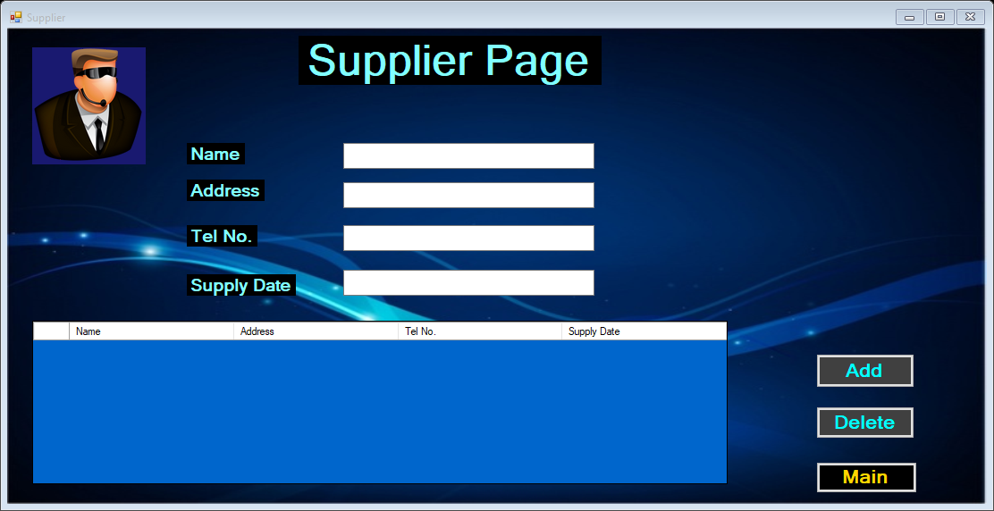

Coding

using System;

using System.Collections.Generic;

using System.ComponentModel;

using System.Data;

using System.Drawing;

using System.Linq;

using System.Text;

using System.Threading.Tasks;

using System.Windows.Forms;

using System.Data.SqlClient;

namespace Stock_Management_System

{

public partial class Supplier : Form

{

SqlConnection con = new SqlConnection(@"Data Source=(LocalDB)\MSSQLLocalDB;AttachDbFilename=C:\Users\YERAN\Documents\Data.mdf;Integrated Security=True;Connect Timeout=30");

public Supplier()

{

InitializeComponent();

}

private void button1_Click(object sender, EventArgs e)

{

this.Hide();

MainMenu ss = new MainMenu();

ss.Show();

}

private void Supplier_Load(object sender, EventArgs e)

{

}

public void disp()

{

SqlCommand cmd = con.CreateCommand();

cmd.CommandType = CommandType.Text;

cmd.CommandText = "select * from Supplier";

cmd.ExecuteNonQuery();

DataTable dt = new DataTable();

SqlDataAdapter da = new SqlDataAdapter(cmd);

da.Fill(dt);

dataGridView1.DataSource = dt;

}

private void button2_Click(object sender, EventArgs e)

{

SqlCommand cmd = con.CreateCommand();

cmd.CommandType = CommandType.Text;

cmd.CommandText = "insert into Supplier values('" + textBox1.Text + "','" + textBox2.Text + "','" + textBox3.Text + "','" + textBox4.Text + "')";

con.Open();

cmd.ExecuteNonQuery();

disp();

MessageBox.Show("Supplier Added Successfully ");

con.Close();

}

private void button3_Click(object sender, EventArgs e)

{

try

{

string Name = textBox1.Text;

string query_delete = "delete from [Supplier] where Name ='" + Name + "'";

SqlCommand cmd = new SqlCommand(query_delete, con);

con.Open();

cmd.ExecuteNonQuery();

disp();

MessageBox.Show("Record Deleted Successfully");

}

catch (Exception ex)

{

MessageBox.Show("Error While Deleting !" + ex);

}

finally

{

con.Close();

}

}

}

}

3.7. Manager page

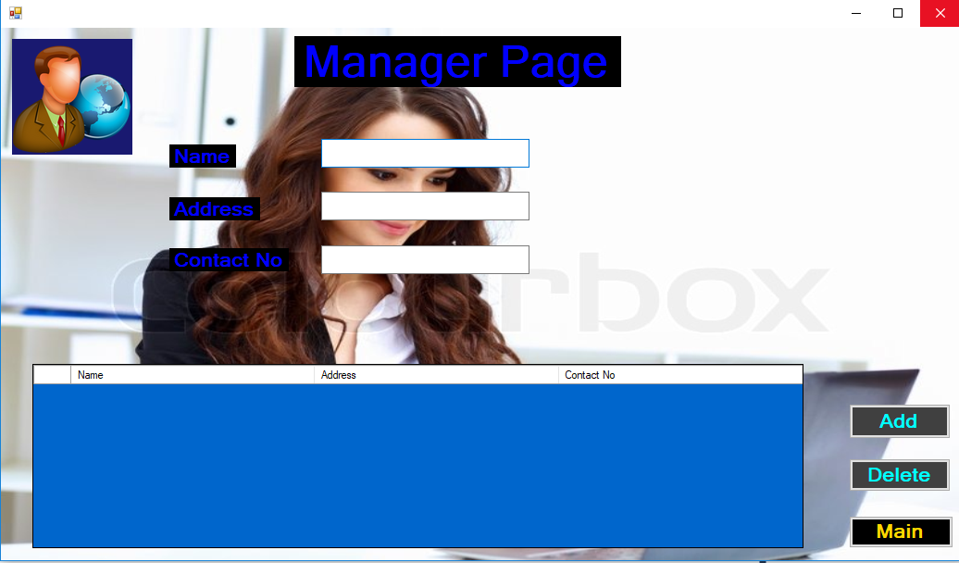

Coding

using System;

using System.Collections.Generic;

using System.ComponentModel;

using System.Data;

using System.Drawing;

using System.Linq;

using System.Text;

using System.Threading.Tasks;

using System.Windows.Forms;

using System.Data.SqlClient;

namespace Stock_Management_System

{

public partial class Managercs : Form

{

SqlConnection con = new SqlConnection(@"Data Source=(LocalDB)\MSSQLLocalDB;AttachDbFilename=C:\Users\YERAN\Documents\Data.mdf;Integrated Security=True;Connect Timeout=30");

public Managercs()

{

InitializeComponent();

}

private void button1_Click(object sender, EventArgs e)

{

this.Hide();

MainMenu ss = new MainMenu();

ss.Show();

}

private void button3_Click(object sender, EventArgs e)

{

try

{

string Name = textBox1.Text;

string query_delete = "delete from [Manager] where Name ='" + Name + "'";

SqlCommand cmd = new SqlCommand(query_delete, con);

con.Open();

cmd.ExecuteNonQuery();

disp();

MessageBox.Show("Record Deleted Successfully");

}

catch (Exception ex)

{

MessageBox.Show("Error While Deleting !" + ex);

}

finally

{

con.Close();

}

}

private void button2_Click(object sender, EventArgs e)

{

SqlCommand cmd = con.CreateCommand();

cmd.CommandType = CommandType.Text;

cmd.CommandText = "insert into Manager values('" + textBox1.Text + "','" + textBox2.Text + "','" + textBox3.Text + "')";

con.Open();

cmd.ExecuteNonQuery();

disp();

MessageBox.Show("Manager Added Successfully ");

con.Close();

}

private void Managercs_Load(object sender, EventArgs e)

{

}

public void disp()

{

SqlCommand cmd = con.CreateCommand();

cmd.CommandType = CommandType.Text;

cmd.CommandText = "select * from Manager";

cmd.ExecuteNonQuery();

DataTable dt = new DataTable();

SqlDataAdapter da = new SqlDataAdapter(cmd);

da.Fill(dt);

dataGridView1.DataSource = dt;

}

}

3.8. Customer order page

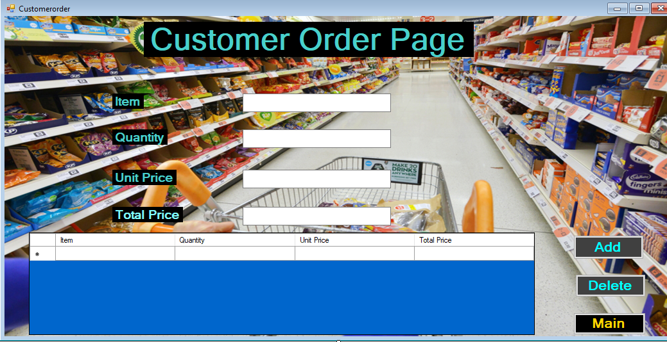

Coding

using System;

using System.Collections.Generic;

using System.ComponentModel;

using System.Data;

using System.Drawing;

using System.Linq;

using System.Text;

using System.Threading.Tasks;

using System.Windows.Forms;

using System.Data.SqlClient;

namespace Stock_Management_System

{

public partial class Customerorder : Form

{

SqlConnection con = new SqlConnection(@"Data Source=(LocalDB)\MSSQLLocalDB;AttachDbFilename=C:\Users\YERAN\Documents\Data.mdf;Integrated Security=True;Connect Timeout=30");

public Customerorder()

{

InitializeComponent();

}

private void button1_Click(object sender, EventArgs e)

{

this.Hide();

MainMenu ss = new MainMenu();

ss.Show();

}

private void Customerorder_Load(object sender, EventArgs e)

{

}

public void disp()

{

SqlCommand cmd = con.CreateCommand();

cmd.CommandType = CommandType.Text;

cmd.CommandText = "select * from Customero";

cmd.ExecuteNonQuery();

DataTable dt = new DataTable();

SqlDataAdapter da = new SqlDataAdapter(cmd);

da.Fill(dt);

dataGridView1.DataSource = dt;

}

private void button2_Click(object sender, EventArgs e)

{

SqlCommand cmd = con.CreateCommand();

cmd.CommandType = CommandType.Text;

cmd.CommandText = "insert into Customero values('" + textBox1.Text + "','" + textBox3.Text + "','" + textBox2.Text + "','" + textBox4.Text + "')";

con.Open();

cmd.ExecuteNonQuery();

disp();

MessageBox.Show("Customer Order Added Successfully ");

con.Close();

}

private void button3_Click(object sender, EventArgs e)

{

if (e == null)

{

throw new ArgumentNullException(nameof(e));

}

try

{

string Item = textBox1.Text;

string query_delete = "delete from [Customero] where Item ='" + Item + "'";

SqlCommand cmd = new SqlCommand(query_delete, con);

con.Open();

cmd.ExecuteNonQuery();

disp();

MessageBox.Show("Record Deleted Successfully");

}

catch (Exception ex)

{

MessageBox.Show("Error While Deleting !" + ex);

}

finally

{

con.Close();

}

}

}

}

3.9. Stock details page

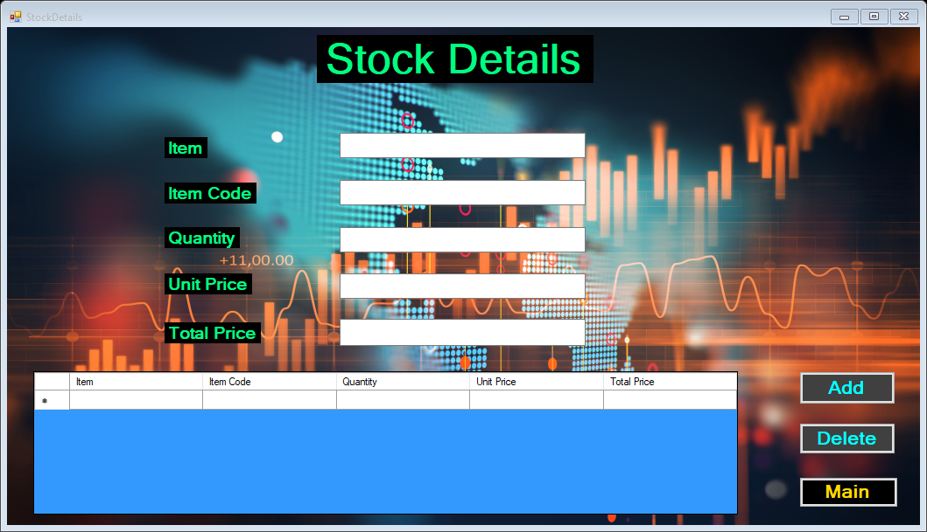

Coding

using System;

using System.Collections.Generic;

using System.ComponentModel;

using System.Data;

using System.Drawing;

using System.Linq;

using System.Text;

using System.Threading.Tasks;

using System.Windows.Forms;

using System.Data.SqlClient;

namespace Stock_Management_System

{

public partial class StockDetails : Form

{

SqlConnection con = new SqlConnection(@"Data Source=(LocalDB)\MSSQLLocalDB;AttachDbFilename=C:\Users\YERAN\Documents\Data.mdf;Integrated Security=True;Connect Timeout=30");

public StockDetails()

{

InitializeComponent();

}

private void button1_Click(object sender, EventArgs e)

{

this.Hide();

MainMenu ss = new MainMenu();

ss.Show();

}

private void StockDetails_Load(object sender, EventArgs e)

{

}

public void disp()

{

SqlCommand cmd = con.CreateCommand();

cmd.CommandType = CommandType.Text;

cmd.CommandText = "select * from Stock";

cmd.ExecuteNonQuery();

DataTable dt = new DataTable();

SqlDataAdapter da = new SqlDataAdapter(cmd);

da.Fill(dt);

dataGridView1.DataSource = dt;

}

private void button2_Click(object sender, EventArgs e)

{

SqlCommand cmd = con.CreateCommand();

cmd.CommandType = CommandType.Text;

cmd.CommandText = "insert into Stock values('" + textBox1.Text + "','" + textBox2.Text + "','" + textBox3.Text + "','" + textBox4.Text + "','" + textBox5.Text + "')";

con.Open();

cmd.ExecuteNonQuery();

disp();

MessageBox.Show("Stocks Added Successfully ");

con.Close();

}

private void button3_Click(object sender, EventArgs e)

{

try

{

string Item = textBox1.Text;

string query_delete = "delete from [Stock] where Item ='" + Item + "'";

SqlCommand cmd = new SqlCommand(query_delete, con);

con.Open();

cmd.ExecuteNonQuery();

disp();

MessageBox.Show("Record Deleted Successfully");

}

catch (Exception ex)

{

MessageBox.Show("Error While Deleting !" + ex);

}

finally

{

con.Close();

}

}

}

}

3.10. Logout page



Coding

using System;

using System.Collections.Generic;

using System.ComponentModel;

using System.Data;

using System.Drawing;

using System.Linq;

using System.Text;

using System.Threading.Tasks;

using System.Windows.Forms;

namespace Stock_Management_System

{

public partial class Logout : Form

{

public Logout()

{

InitializeComponent();

}

private void button1_Click(object sender, EventArgs e)

{

this.Hide();

Application.Exit();

}

private void Logout_Load(object sender, EventArgs e)

{

}

}

}